- INTRODUCTION.
- PART 1: SETTING UP THE PROJECT.
- PART 2: DEFINE THE MODELS.
- PART 3: CREATE NEW CATEGORIES USING THE ADMIN AREA.
- PART 4: STRUCTURE THE APP ROUTES AND CLASS-BASED VIEWS.
- PART 5: CREATE THE TEMPLATES.
INTRODUCTION, In this tutorial, I will show you how to build a totally functional CRUD (Create-Read-Update-Delete) application with Django by using one of its most powerful features: the Class-based Views (CBV). That approach maximizes code reuse and allows you to build Django apps much faster and more efficiently.
So, without any delay, let’s get started. We will create a simple app to manage information about films and its genres. If you desire, access the complete code on my GitHub repository here. Or keep reading and follow the steps presented below. I’m using GitBash for Windows as my terminal, so some commands here might need to be adapted to your preferred terminal, especially if you are using Power Shell or Windows Command Prompt. https://github.com/fabricius1/DjangoFilmsCRUD
PART 1: SETTING UP THE PROJECT
1. Create your project folder and move inside it. I called mine films_project.
mkdir films_project
cd films_project
2. Create a new virtual environment with venv (mine is called .myenv).
python -m venv .myenv
3. Now activate your virtual environment. The command below works on the GitBash. Consult this Python documentation page to check the command for both your terminal and OS. source .myenv/Scripts/activate
4. Install the Python packages we will need for this project:
pip install django django-extensions
5. Create a requirements.txt file. You can use the following command:
pip freeze | grep -i django >> requirements.txt
6. Start a new Django project. Mine is just called project. Don’t forget to add the dot at the end of this command.
django-admin startproject project .
7. Start a Django app called films.
python manage.py startapp films
8. Open project/settings.py and add django_extensions and the films app o the INSTALLED APPS list . Don’t change the other lines.
INSTALLED_APPS = [
'django.contrib.admin',
'django.contrib.auth',
'django.contrib.contenttypes',
'django.contrib.sessions',
'django.contrib.messages',
'django.contrib.staticfiles', # add these lines:
'django_extensions',
'films.apps.FilmsConfig',
]
9. Apply the migrations to create the tables in the sqlite3 database.
python manage.py migrate
10. Create a superuser by running the following command:
python manage.py createsuperuser
Inform an username, email, and password. You’ll use this data to login in the admin area later.
11. Run the server with python manage.py runserver , visit http://localhost:8000 and check if the app is working correctly.
12. Go to http://localhost:8000/admin , use your login data and check if you can access the admin area.
PART 2: DEFINE THE MODELS. 13. In films/models.py, enter the following code:
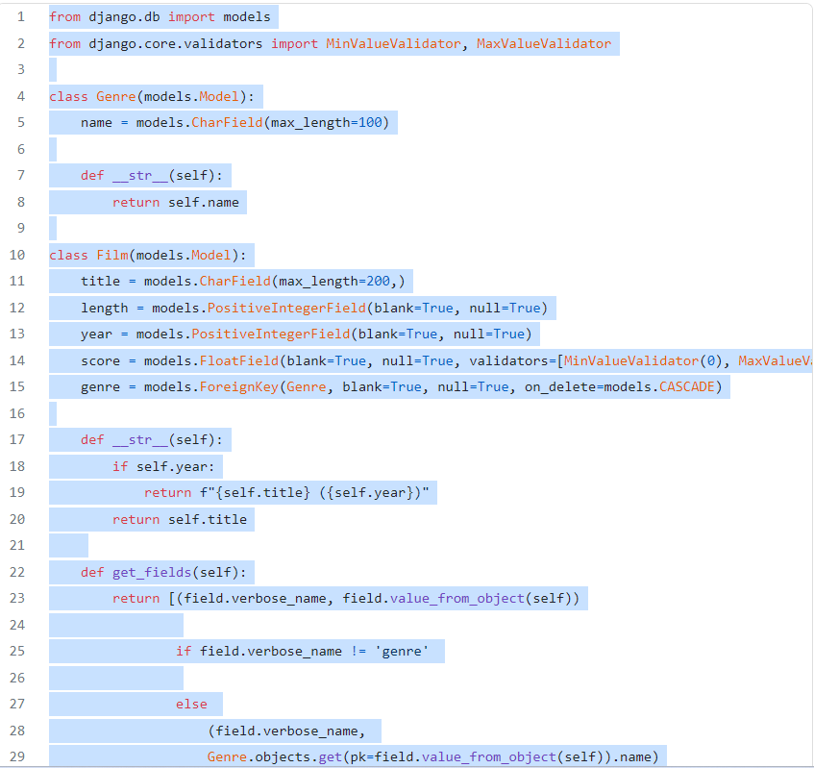
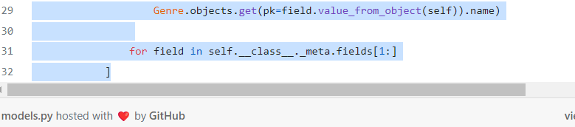
We are creating two model classes(Film and Genre), with a simplified relationship between them, since one film can have just one genre here. In the future, you can change to a many-to-many relationship between these tables, if you want, or you can even add other entities to the model, like directors or awards.
In the Films class, notice the important get_fields() method. This will create a list of label/value pairs for every column in the films_film table but the id, a structure that we can use in a for loop inside the future film_detail.html template. Such a structure could be even more helpful if we had dozens or even hundreds of columns in a model, so this code might be worth saving for future projects.
PART 3: CREATE NEW CATEGORIES USING THE ADMIN AREA
14. Run the commands to create the new tables in the database:
python manage.py makemigrations
python manage.py migrate
15. Open films/admin.py and write these lines. Now the Films and Genre models will become available in the admin area:
from django.contrib import admin
from .models import Film, Genreadmin.site.register(Film)
admin.site.register(Genre)
16. Next, login to the admin area, select the Genre model, then create and save two or three new genres. We will need these genres later, when we use the films CRUD to save new movies.
PART 4: STRUCTURE THE APP ROUTES AND CLASS-BASED VIEWS
17. Create the films/urls.py file.
18. Open project/urls.py , import the include function and use it to create a new route:
from django.contrib import admin
from django.urls import path, include # addedurlpatterns = [
path('', include('films.urls')), # added
path('admin/', admin.site.urls),
]
19. Next, open films/urls.py and add the following code to it.
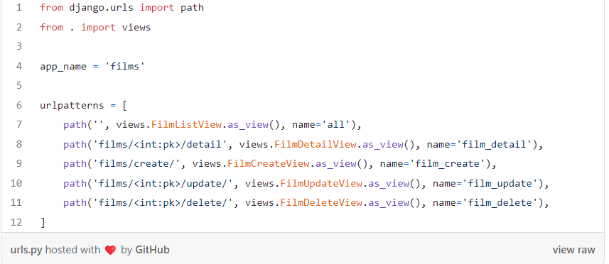
The CBV are not created yet, so running the server at this point will generate errors.
20. In films/views.py, this code will create the generic CBV that we need:
ice how concise this code is: we only create a FilmBaseView so that we don’t repeat the model, fields and success_url info lines, then we make our Film View Classes inherit from both FilmBaseView and the respective Generic View Classes that Django already has for doing CRUD operations. All that with no need of working with forms logic, or writing code to access the database and then save this info in a context dictionary. Those procedures are already worked out by Django’s CBV. With the advantage that we can always modify any of their methods and add new behavior to the View Classes depending on our specific needs.
Now we only need to create the templates to display and change the information provided by our Film Class Views.
PART 5: CREATE THE TEMPLATES
21. Open project/settings.py and, in the variable TEMPLATES, fill the empty list in the TEMPLATES['DIR'] key with the following information (change only this one line, keeping the other untouched):
TEMPLATES = [
{(...)'DIRS': [ BASE_DIR.joinpath('templates') ],(...)}
]
22. Make sure you are in the root project (folder films_project, at the same level as manage.py), then create these three new folders.
mkdir templates films/templates films/templates/films
Now, it is time to create the HTML files we will use as templates to the films CRUD. However, before we do that, a pratical observation: as a matter of fact, I think that it will be better not to reproduce the templates code here, since most of it is too long. So, I will provide some links to the raw content from each template file saved on my GitHub repository, so that you can copy/paste or transcribe it to your own code.
23. Create a templates/base.html file. This file should not be inside the films template folder, be careful with that.
- touch templates/base.html (content here);
24. Inside the films/templates/films folder, create four files with the exact following names, since those are the template names patterns used by Django’s generic Views:
- film_confirm_delete.html (content here);
- film_detail.html (content here);
- film_form.html (content here);
- film_list.html (content here);
You can create these files at once by running just this line of code in a Linux terminal (or Git Bash):
touch films/templates/films/film_{confirm_delete,detail,form,list}.html
Notice how these HTML file names are prepended with film_ , which is our model name in smallcaps followed by an underscore. You should use this pattern when creating CRUD applications with CBV in future Django projects.
25. Run python manage.py check to see if there are any errors; then run the server with python manage.py runserver. Your CRUD films application is finished and now you can list, add, update and delete films information with it.
PART 6: ADD SOME EXTRA FILMS TO YOUR DATABASE USING A PYTHON SCRIPT. Explore your new app and make some changes on it. If you want extra data to play with, you can load to Django a list of more than 20 Pixar movies I prepared. You just need to follow these steps:
26. Create a scripts folder at the same level of manage.py
27. Create a films/pixar.csv file and copy this content into it.
28. Create a scripts/load_pixar.py file and copy this content into it.
29. Run python manage.py runscript load_pixar. Access your films app and check how it is populated with the Pixar movies info now.
If you want to know more about running Python scripts in Django, I invite you to read this other tutorial I wrote:

Use Python Scripts to Insert CSV Data into Django Databases

Django-extensions is the tool you were looking for towardsdatascience.com
FINAL REMARKS: MAKE YOUR OWN DJANGO CRUD APPS
You have now all the necessary tools to build more complex Django CRUD apps with your own models.
For example, imagine you have three tables: Institutions, Projects, and Courses. One institution can submit multiple projects and one project can have one or more courses vinculated to it.
To make a Django CRUD in this context, you just need to follow the steps we discussed above for these three entities, in a new Django project:
- Define the models in a models.py file;
- In a urls.py file, create five routes for each model, following the patterns we showed. Since we have three models, you would have fifteen routes in total, and maybe one more for a home page. You could put links in a navigation bar to go directly to the respective list all pages of Institutions, Projects and Courses.
- Put all the necessary code in views.py. We created six Class-based Views for Films, so we would have 18 CBV in total: 6 for Institutions, 6 for Projects and 6 for Courses, all in the same file.
- Finally, just create the 12 template files for your CRUD (4 for each model), following the HTML name patterns and making the necessary changes in the templates HTML code.
Once you have this Films starter code, it is very easy and fast to copy code for your own projects and make the necessary adjustments for your specific needs.
I myself had a very nice experience recently, when I managed to build the almost exact CRUD I described above to my wife in just a few hours of work. And the models.py became a huge one, with more than fifty columns just the Courses model, for example. So, I spent most of my time modeling the data; once it was done, it became super simple and fast to put the CRUD app up and running.
My wife and I will still discuss some adjustments and improvements before this code goes to production, but such an experience was enough to show me how easy it is to build CRUD apps with Django. If you combine what you learned here with a nicier and more elaborated Front End, you might surprise positively clients or prospective employers with your new Django coding skills.
Thank you so much, dear reader, for having honored my text with your time and attention. Happy coding!

https://github.com/fabricius1/DjangoFilmsCRUD

https://towardsdatascience.com/build-a-django-crud-app-by-using-class-based-views-12bc69d36ab6 Youtube

Build a Django CRUD Application with Class Based Views

CRUD Completo con Django y SQLite3: ORM, Bootstrap, JavaScript

Sitio web con python | CRUD django mysql
<header>
<!-- place navbar here -->
<nav class="navbar navbar-expand navbar-light bg-light">
<div class="nav navbar-nav">
<a class="nav-item nav-link active" href="#" aria-current="page">Home <span class="visually-hidden">(current)</span></a>
<a class="nav-item nav-link active" href="#">Inicio </a>
<a class="nav-item nav-link active" href="#">Libros </a>
<a class="nav-item nav-link active" href="#">Nosotros </a>
</div>
</nav>

